Memorandum - Split Combinations

September 11, 2015

The process of splitting/combining a parcel is done as a courtesy to the owner to make land more usable to them or allow them to sell a portion of it, but the current split/combination process for St. Clair County does not properly address the issue of collection for current year taxes.

To correct this problem and eliminate further tax write offs, it is the recommendation of the County Treasurer that after the June 1st when the Treasurer tax roll is committed that when an Assessor approves and issues a split that they provide a copy of the Courtesy Split Bill to the City or Township Treasurer to issue a billing on the newly split parcels for current year taxes. This type of billing can be done at any time of year.

It is our recommendation that the Courtesy Split Bill be used as authorization by the local treasurers to add the new parcels to their roll and zero out the parent parcel that is being retired. Treasurers have been provided with BS&A instructions for completing this process and our office is available for questions on how to address more complex split situations.

By adding the new parcels to the tax roll it ensures that these splits are properly taxed and collected. It also ensures that the County Treasurer can retain the authority to foreclose on the parcels if an owner fails to pay the tax bill.

If you have any questions on this recommendation please don’t hesitate to contact our office.

Respectfully,

Molly Tierney Crorey

St. Clair County Deputy Treasurer

**BS&A - SPLIT/COMBO INSTRUCTIONS**

1. Run a copy of your Adjusted Tax Roll to determine existing Taxable and SEV Values
2. Start by clicking the ADD button to create a new children parcel in the system.
   1. When prompted about adding due to a Split\Combo click YES.
      1. By answering “YES” the system will bring up a new window that allows for the parent parcel numbers to be filled in for reference.
   2. Repeat this process for all child parcels related to the Split/Combo
3. Next an adjustment for each parcel related to the split/combo must be done to increase/decrease the Taxable and SEV Values.
4. Adjustments are found under “Adjustments” tool and then select Split Combo

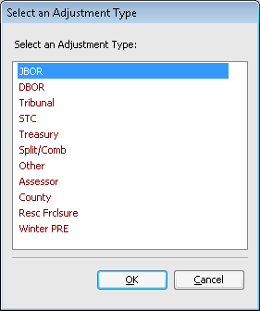

1. The adjustment for parent parcel will be to reduce the value to zero
   1. To change the values check the box for “Adjust Taxable Value” and “Adjust Assessed Value” and leave the value at zero

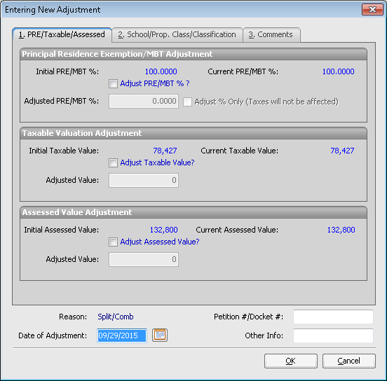

* 1. The system will pop up with an Adjustment Option for:
     1. Winter Only or All Seasons
     2. Note that Winter Only should be used when the Summer taxes have been paid in full

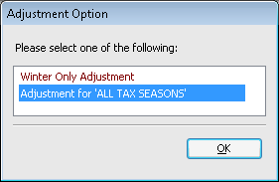

1. For the child parcels the adjustment will be to increase the value by a percentage of the value that is being transferred from the parent to each individual child parcel.
   1. This percentage calculation may be complex depending on how many parent/child splits are being done, but this is the statutory responsibility of the Assessor to determine the appropriate value and include on the Courtesy Billing.
2. Repeat Step 5A and 5b for each child parcel to assign the proper values for Taxable and SEV
3. Rerun your Tax roll
   1. It is important to note that a split/combo adjustment **never** results in a change in overall Roll Value for the current year